**[Pet center arduino](https://github.com/ZiqinGao/pet-center-arduino/upload/master/)**

**Specific steps and instructions**

This is a simple project made by using Arduino UNO R3

**1.One Arduino UNO R3 and one sensor control two micro servo**

**Step 1: Parts List**

One Arduino UNO R3  
One HC-SR04 Ultrasonic Sensor  
One Red LED  
One Green LED  
One half Breadboard  
Jump lines  
Two micro servo

## Step 2: Connect the sensor and make sure it works

Connect the sensor and use the Arduino libraries as resource to make to it works.

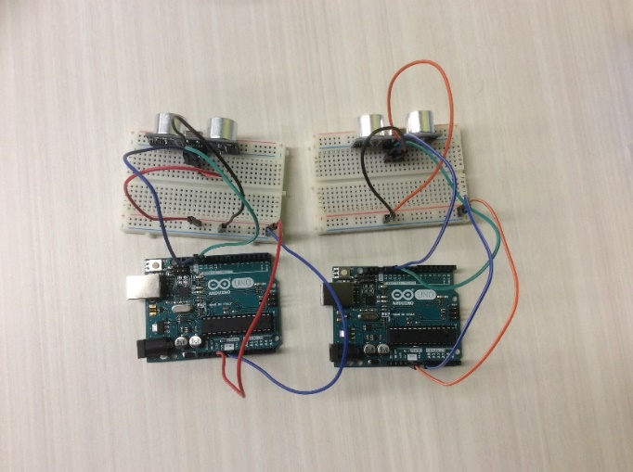

**Step 3: Test your sensor and led lights**

Use “Simple Arduino and HC-SR04 Example”, which creat by jsvester in Arduino.(URL: http://www.instructables.com/id/Simple-Arduino-and-HC-SR04-Example/ )as the guide to build and test the sensor and led lights. The sensor will measure the distance, if the distance is less than or equal to 5cm the red LED lights; otherwise, the green LED light will light.

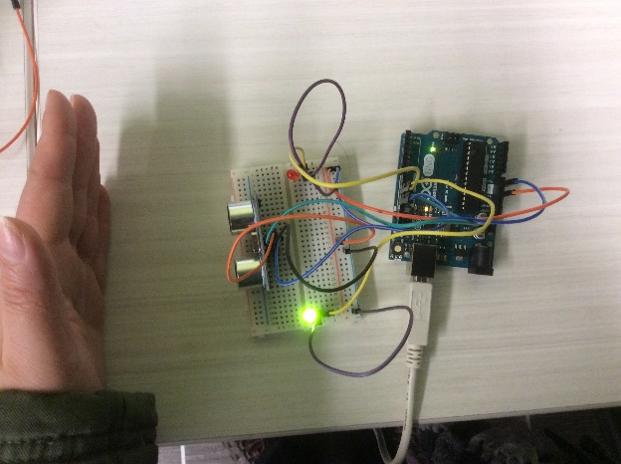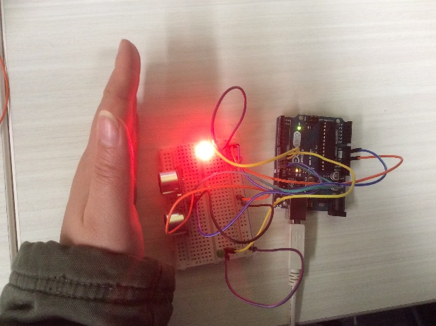

## Step 4: Connect the components

Connect the components and wires as shown in the two pictures.

After you succeeded to connect a micro servo. The sensor could control micro servo to action, when the distance is less than or equal to 5cm, the red LED will light and the micro servo rotate 180 degrees and reset back. On another hand, when the green LED light (the distance is greater than 5cm), micro servo do nothing. Then you can connect another micro servo.

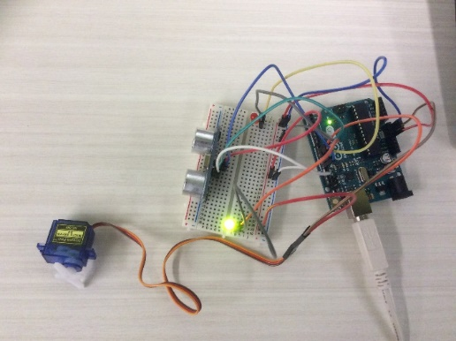

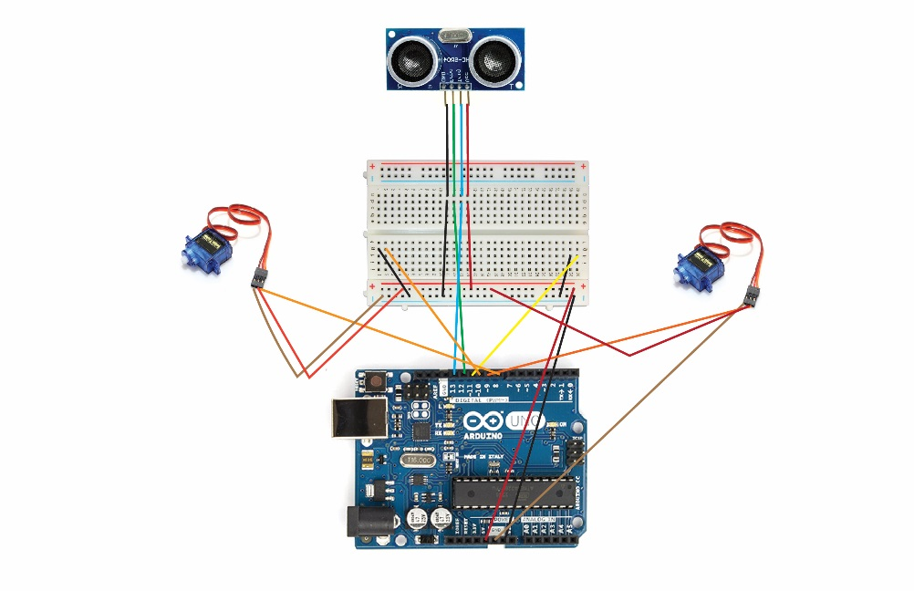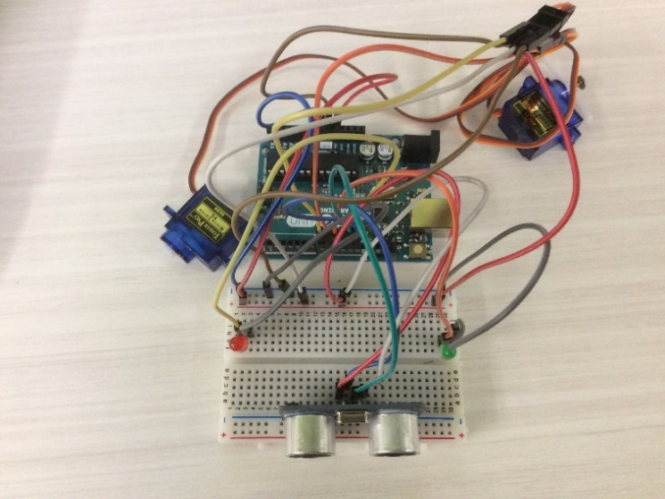

**Step 5: Upload the code**

Upload the code: arduino code to arduino code(one sensor control two micro servo)

**2.One Arduino UNO R3 and two sensor control two micro servo separately**

**Step 1: Parts List**

One Arduino UNO R3  
Two HC-SR04 Ultrasonic Sensor  
Two Red LED  
Two Green LED  
Two to three half Breadboard  
Jump lines  
Two micro servo

## Step 2: Connect the sensor and make sure it works

**Step 3: Test your sensor and led lights**

(Create Step 2&3 in the same step as the previous.)

## Step 4: Connect the components

Connect the components and wires as shown in the pictures.

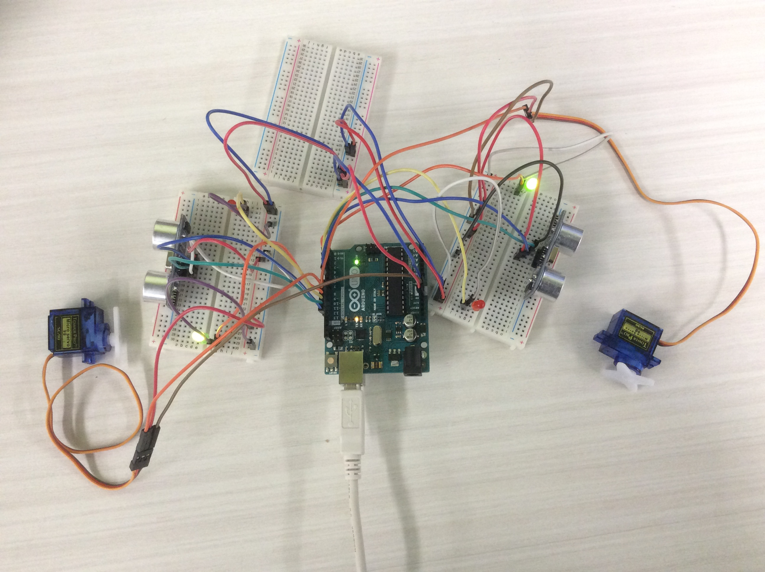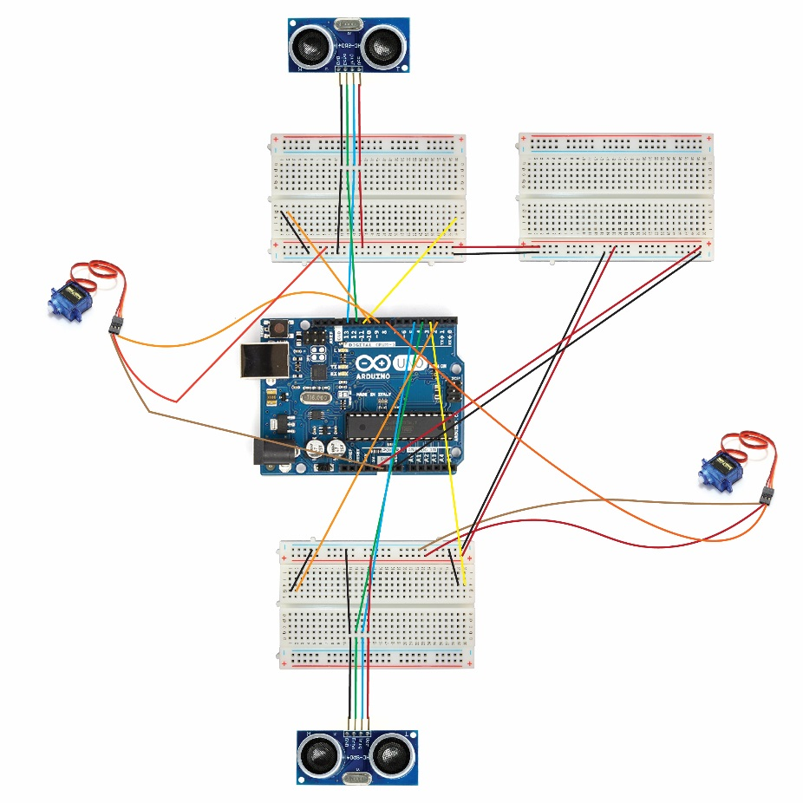

**Step 5: Upload the code**

Upload the code: [arduino code (two sensor control two micro servo separately)](https://github.com/ZiqinGao/pet-center-arduino/commit/5c58e7397f0f5a36be0e2ff2ae0141ffaf30d3aa)